Ebbett Park School

Charter and Strategic Direction

2021

Ebbett Park School Background

Ebbett Park School was opened in 1960 and is situated on the southern boundary of Hastings.

Ebbett Park School is situated in the suburb of Raureka. It is a contributing primary school catering for children from Years 1 – 6. It currently has a roll of approximately 180 children with an ethnic mix of Maori, Pacifica and European students, all of whom contribute to the overall positive culture of the school. The school draws its pupils from a range of socio and economic groups. Many of our students come from all over Hastings.

Our core values of EXCELLENCE, PRIDE & SPIRIT are embedded in our beliefs and systems. We are proud to be a PB4L school, currently in our second year of Tier 2. At Ebbett Park School you will see settled classrooms with engaged learners. We have an outstanding team of teachers who work extremely hard to provide engaging learning situations for our students.

The predominately Maori community is very supportive and is involved in many aspects of school life. The school prides itself on its ability to provide positive class pupil/teacher ratios as one strategy in enhancing learning opportunities. We have an amazing Kapa Haka ropu with a focus on performance and tikanga.

We are well known through the country as a school that provides outstanding school-wide inclusiveness. This has been best seen through Ebbett Park School becoming the pilot school for The Van Asch Deaf Education Centre in setting up NZSL communicators for students with hearing issues. We currently have three Deaf Communicators supporting our students.

Ebbett Park School Mission

Ebbett Park School will challenge students to excel and provide them with all they require to be lifelong learners.

Ebbett Park School Values
Excellence | Excellence in my attitude  Excellence in my behaviour  Excellence in my learning
Pride | Pride in myself  Pride in my school  Pride in my community
Spirit | Spirit in my individuality  Spirit in my relationships  Spirit in my team work
How Ebbett Park School relate to the New Zealand Curriculum’s key Competencies
Relating to Others | Be a good listener  Manage and resolve conflict  Take on a range of roles in group including leadership  Accept people’s differences  Be open to new learning and accept that being wrong is part of the process
Managing Self | Set goals  Are self-motivated and have a ‘can do’ attitude  Make good choices  Listen to others  Be reflective
Thinking | Seek problems  Are curious  See problems as interesting  Use our imaginations/creativity/prior knowledge to come up with solutions to problems  Use thinking models to help us think  Ask questions
Participating and Contributing | Respond appropriately as a group member  Understands the rights and responsibilities of being a group member  Creates opportunities to include others
Using Language, symbols and text. | Seeks and gathers information from a variety of sources  Sorts, selects and records valid information  Presents coherent and structured information

How Ebbett Park School relates to the New Zealand Curriculum Principles
 | Teachers | Students
High expectations | Model and provide examples of excellence.  Believe that all students can achieve at their best.  Give maximum effort and motivation and show positivity towards learning.  Model being a lifelong learner. | Keep up-to-date with their work.  Do their best at all times.  Model excellence to others.  Look for better ways to do something.  Feel confident that they are doing what they can to improve.  Be able to state their next steps.  Set goals.
Treaty of Waitangi | Include a Maori perspective in planning  Include Maori contexts in learning  Pronounce Maori vocabulary correctly  Show interest in Maori themes/contexts  Direct parental request from parents for their child to receive instruction in Te Reo Maori | Pronounce Maori vocabulary correctly  Show interest in Maori themes/contexts  Parents will be given assistance and support to access such a programme through correspondence school and/or supported to develop a relationship with Kura Kaupapa
Cultural Diversity | Make learning contexts relevant to all students. | Respect other cultures  Not be racist to other cultures
Inclusion | Ensure that all students regardless of their age, race or gender will achieve at their best and have their learning needs met. Recognise and acknowledge students talents and achievements.  Inclusion Initiatives are put in place to support students. | Include everyone in activities  Do their best in all areas.  Achieve and feel that they are being acknowledged for their achievement  Receive praise, feedback and certificates
Learning to Learn | Reflect on their own practice and encourage students to reflect on theirs.  Have observations completed on their teaching and next steps identified.  Assess alongside students and help them be aware of their next steps.  Encourage self and peer assessment.  Use a variety of approaches and strategies in their teaching. | Pay attention in class  Reflect on what they have done and how they can improve  Set goals and work towards achieving them  Discuss learning with others  Help others  Observe others  Use a variety of strategies and tools
Community Engagement | Involve the community in the students’ next learning steps.  Encourage community input into the curriculum and classroom.  Report to the community on achievement.  Reporting whole school parent/teacher meetings midyear  Clear reporting to parents twice a year. | Help involve their parents in their learning  Ask parents to provide support if it is needed  Get community input into possible learning contexts and themes.
Coherence | Help students to make connections between their learning, next steps and real life contexts.  Encourage inquiry and exploration. | Be encouraged and not be forced to do things  Know what they are learning and why they are learning it.  Connect between their learning, next steps and real life contexts
Future Focus | Let students know how the curriculum can be used in their futures. Connect what they are doing to real life contexts.  Provide financial knowledge and experiences.  Teachers connecting to latest educational ideas and practice  Teachers exploring digital technologies to support learning. | Relate learning to future careers  Focus on the future not the past  Give students the opportunity to learn about things that that interest them  Understanding how the curriculum can be used in their future  Develop financial literacy

Ebbett Park School Strategic Plan 2019 – 2021: REVIEWED
Review Key: NA=Not Achieved, SWA=Somewhat achieved, A=Achieved, OG=Ongoing

The information below has been a result of the school based self review around these dimensions of teaching: Student achievement, quality of teaching, behaviour and safety, leadership and management, professional development and overall effectiveness, including the promotion of the pupil’s moral, social and cultural development. These replace the strategic plan goals set prior to the change in management.
Strategic Goal | Strategic Outcomes | Actions 2019 – 2020 - 2021 | Indicators
ACADEMIC  Extend student achievement in Literacy and Numeracy across the school through Formative Assessment practices | - Learning programmes foster student achievement  - All students are provided opportunities to achieve success and reach their full potential  - Students have positive feelings toward reading, writing and mathematics | - Robust testing/assessment of student achievement to ensure targeted tuition. SWA  - Develop targeted planning A & OG  - Monitoring of targeted planning SWA/OG  - Maintain solid moderation practices. NA  - Use of achievement data to target teaching for optimal effect – Formative assessment SWA & OG  - Develop and build school-wide understanding about what constitutes accelerated progress and achievement SWA  - Ensure Deliberate Acts of Teaching are evident in teacher structured sessions SWA  - Reflections, notes and next steps evident in planning (planning as a working document) SWA  - Peer coaching practices NA | - Enhanced engagement in the 3 core learning areas  - Students will be able to articulate their own learning needs and what they have to do to achieve them  - Students will experience flexible grouping with their learning style being catered for  - Increased confidence in students own learning abilities and being proud of their achievements  With the unfortunate event of COVID of focus shifted from academic to the health and well- being of our tamariki. We needed to regain a sense of ‘normal’ and this was challenged through social distancing and regular changes to the way we did things across the different levels throughout the year.
ACADEMIC  All students will be able to effectively access and gain educational value from the Ebbett Park School Curriculum as evidenced by achievement. | - A sound Ebbett Park School Curriculum  - Curriculum providing for all essential learning areas and is culturally responsive. | - Parents to be consulted regarding what the curriculum should look like/focus on. SWA  - Parents are informed of learning aims and progress through seesaw. A & OG | - Student will participate in learning that is designed with them in mind.  - Students will experience learning that is culturally responsive and appropriate  Our staff worked effectively during the year to ensure that work that was set, at all levels of COVID, was academically appropriate and needs based. I was incredibly proud of what they did and how well they managed working online and from home.
CULTURAL  Improve education and achievement of Maori and Pacifica students. | - Programmes that support emotional, physical, social, educational and cultural needs are developed and implemented.  - Culturally aware and responsive staff. | - Use student achievement data to target resources for optimal effect SWA  - Learner agency/student choice evident in classrooms – culturally responsive practice. SWA & OG  - Integrate elements of students’ identity, language and culture into the curriculum teaching and learning. SWA  - Provide early, intensive support for those students who are at risk of falling behind. SWA & OG  - Create productive partnerships with parents, whanau, hapu, iwi, communities and  businesses that are focused on educational success OG  - Retain high expectations of students to succeed in education as Maori A & OG | - Students will experience learning that is culturally responsive and appropriate for who they are and their beliefs  - Students will participate in targeted programmes that are designed to benefit their needs  Our staff worked effectively during the year to ensure that work that was set, at all levels of COVID, was academically appropriate and needs based. I was incredibly proud of what they did and how well they managed working online and from home.
LEARNING  Develop proficiency in use of technologies with the school environment for learning, presenting, assessment and communication of achievement | - Using technology for information and knowledge in order to access, retrieve, store, organise, manage, synthesise, integrate, present, share, exchange and communicate in multiple formats, either textual or multimedia.  - Create the opportunity to become proficient users of digital technologies to support learning. Effectively us eLearning to support student learning, including engagement with family and whanau. | - Classroom and individual to show learning in and around the school through the use of Seesaw SWA & OG  - Student access to technology during class is unlimited. SWA  - Staff to use technologies to support teaching and learning within the classroom as well as personal reflection for teaching and inquiry SWA  - Staff to work through the ‘Digital Passport’ to develop and upskill themselves with the digit curriculum. NA  - Staff to collaborate with planning using digital school format and the use of digital form assessment. SWA | - Students will have access and support to learning when and where they require it.  - Students will be proud effective and efficient 21st century learners.  - Learning successes and progress will be shared with family and students will show pride in all they are doing and learning.  COVID brough 21st learning to the forefront of what EPS does in terms of practice. It has highlighted the digital divide and the BOT, as a result, has moved to establish OYOD/BYOD practice. This is starting with our year 6 class and encouraged in year 4/5. Curriculum programmes will be designed around a 40/60 – 50/50 device / book learning programme in the senior school.
PROFESSIONAL LEARNING  Build and strengthen teacher practices through evidence based learning | - Staff appraisal is based around teacher inquiry which is supporting of the strategic direction of the school.  - Professional learning supports the needs of students and strategic direction  - Teachers are to explore Teaching as Inquiry and share via Appraisal Connector | - Inquiry question derived from achievement data and target group identified and link to PD within school. SWA  - Establish reflective learning using appraisal connector as evidence for staff in regard to ‘Teaching as Inquiry’ and appraisal SWA  - Connection made to ‘Codes of Professional Responsibility’ and evidence to support meeting of them SWA | - Teachers will have ‘targeted students’ that they have directed focus learning and teaching sessions  - Accountability through Teaching as Inquiry will be transparent  - School wide tracking walls will be established  This took place but was hindered by COVID and working from home. However, once we returned to school we were able to continue to move forward with this and progress has been made. It is a work in progress and still needs work in some areas. With the move from teacher appraisal to Professional Learning Journey’s there is going to be an overhaul of what is done and how this is recorded. There will be core expectations around this for EPS.

Ebbett Park School Strategic Plan 2021 - 2023

Strategic Goal | Strategic Outcomes | Actions 2021 - 2023 | Indicators
ACADEMIC  Extend student achievement in Literacy and Numeracy across the school through Formative Assessment practices | - Learning programmed foster student achievement  - All students are provided opportunities to achieve success and reach their full potential  - Students have positive feelings toward reading, writing and mathematics | - Reform of assessment/testing to ensure that triangular data is used and used effectively.  - Monitoring of targeted planning  - Maintain solid moderation practices.  - Use of achievement data to target teaching for optimal effect – Formative assessment  - Develop and build school-wide understanding about what constitutes accelerated progress and achievement  - Develop a school-wide assessment/test programmed that is underpinned by Formative Assessment, regular and planned ‘glances’  - Ensure Deliberate Acts of Teaching are evident in teacher structured sessions  - Reflections, notes and next steps evident in planning (planning as a working document)  - Peer coaching practices | - Enhanced engagement in the 3 core learning areas  - Students will be able to articulate their own learning needs and what they have to do to achieve them  - Students will experience flexible grouping with their learning style being catered for  - Increased confidence in students own learning abilities and being proud of their achievements  - Teachers will be using multiple forms of evidence to ascertain the achievement level of every student in their classroom  - A school-wide assessment and testing guideline will be established.
ACADEMIC  All students will be able to effectively access and gain educational value from the Ebbett Park School Curriculum as evidenced by achievement. | - A sound Ebbett Park School Curriculum  - Curriculum providing for all essential learning areas and is culturally responsive. | - Parents to be consulted regarding what the curriculum should look like/focus on.  - Parents are informed of learning aims and progress through seesaw. This will be done regularly and often and the posts will be used as evidence to support reporting to whanau as required through the NEGs/NAGs. | - Student will participate in learning that is designed with them in mind.  - Students will experience learning that is culturally responsive and appropriate
CULTURAL  Improve education and achievement of Maori and Pacifica students. | - Programmes that support emotional, physical, social, educational and cultural needs are developed and implemented.  - Culturally aware and responsive staff. | - Use student achievement data to target resources for optimal effect  - Learner agency/student choice evident in classrooms – culturally responsive practice.  - Integrate elements of students’ identity, language and culture into the curriculum teaching and learning.  - Provide early, intensive support for those students who are at risk of falling behind.  - Create productive partnerships with parents, whanau, hapu, iwi, communities and  businesses that are focused on educational success  - Retain high expectations of students to succeed in education as Maori | - Students will experience learning that is culturally responsive and appropriate for who they are and their beliefs  - Students will participate in targeted programmes that are designed to benefit their needs
LEARNING  Develop proficiency in use of technologies with the school environment for learning, presenting, assessment and communication of achievement | - Using technology for information and knowledge in order to access, retrieve, store, organise, manage, synthesise, integrate, present, share, exchange and communicate in multiple formats, either textual or multimedia.  - Create the opportunity to become proficient users of digital technologies to support learning. Effectively us eLearning to support student learning, including engagement with family and whanau. | - Classroom and individual to show learning in and around the school through the use of Seesaw  - Student access to technology during class is unlimited.  - Staff to use technologies to support teaching and learning within the classroom as well as personal reflection for teaching and inquiry  - Staff to collaborate with planning using digital school format and the use of digital form assessment. | - Students will have access and support to learning when and where they require it.  - Students will be proud effective and efficient 21st century learners.  - Learning successes and progress will be shared with family and students will show pride in all they are doing and learning.
PROFESSIONAL LEARNING  Build and strengthen teacher practices through evidence based learning | - Staff appraisal is based around teacher inquiry which is supporting of the strategic direction of the school.  - Professional learning supports the needs of students and strategic direction  - Teachers are to explore Teaching as Inquiry and share via Appraisal Connector | - Inquiry question derived from achievement data and target group identified and link to PD within school.  - Establish reflective learning using appraisal connector as evidence for staff in regard to ‘Teaching as Inquiry’ and appraisal  - Connection made to ‘Codes of Professional Responsibility’ and evidence to support meeting of them  - Staff will participate in ‘Essential Assessment’, an online learning programme provided by ‘Evidence Based Education’. This will lead to reforming our school wide testing and assessment programme/guidelines. | - A school-wide assessment and testing guideline will be established.  - Teachers will have ‘targeted students’ that they have directed focus learning and teaching sessions  - Accountability through Teaching as Inquiry will be transparent  - School wide tracking walls will be established

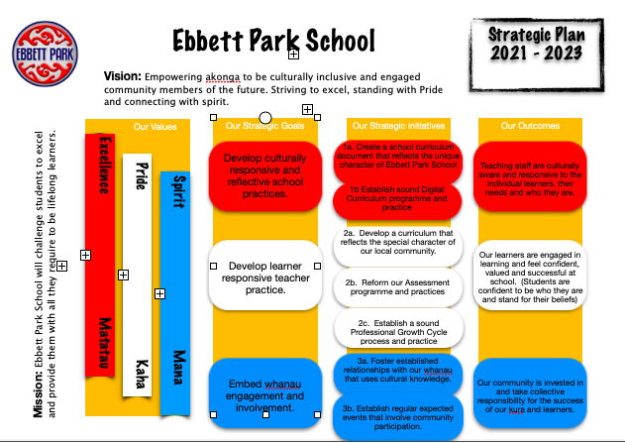
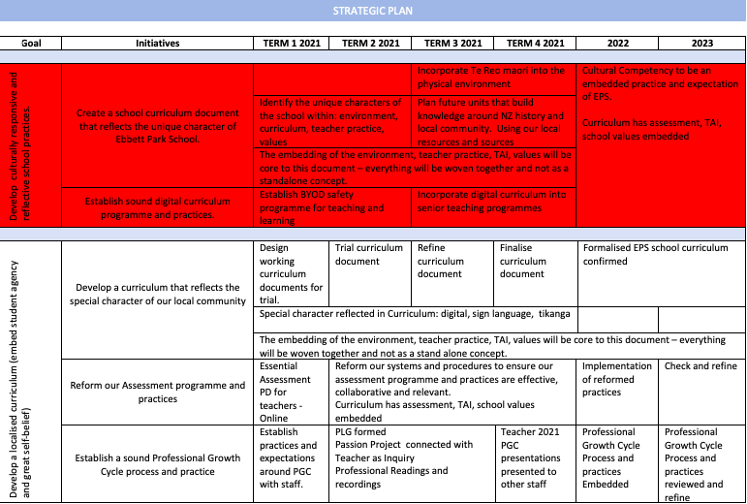
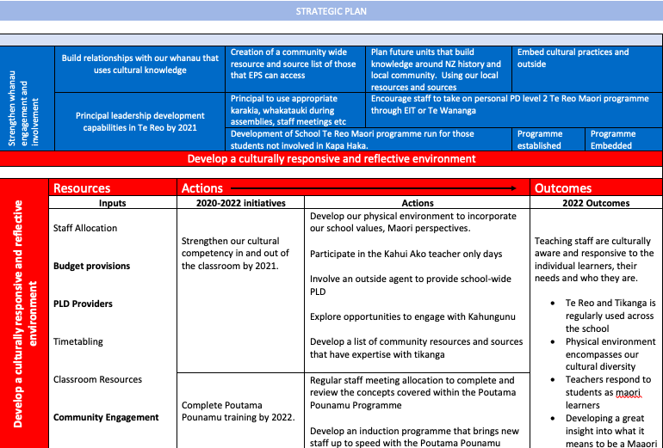
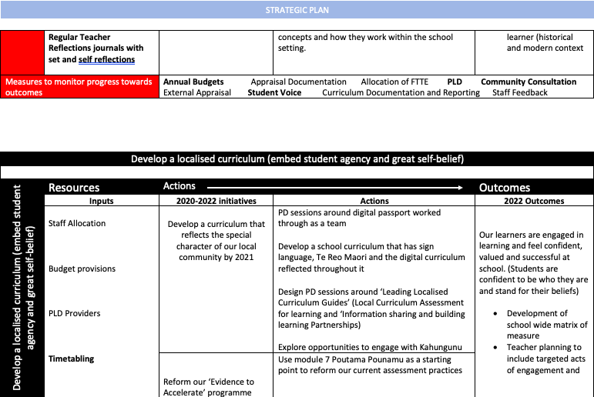
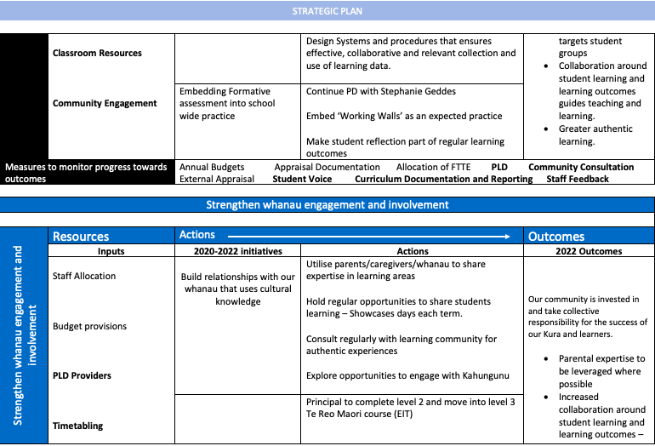
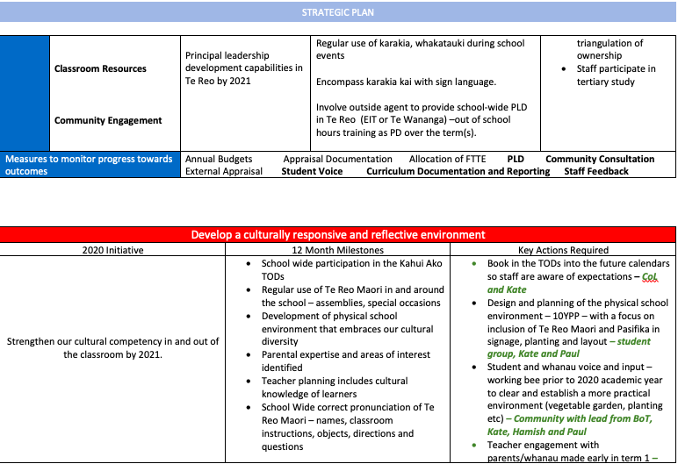
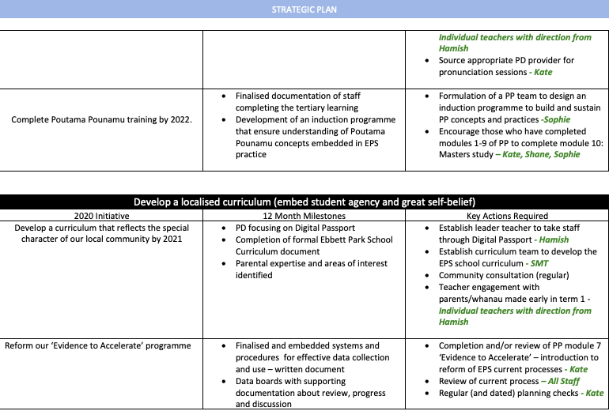
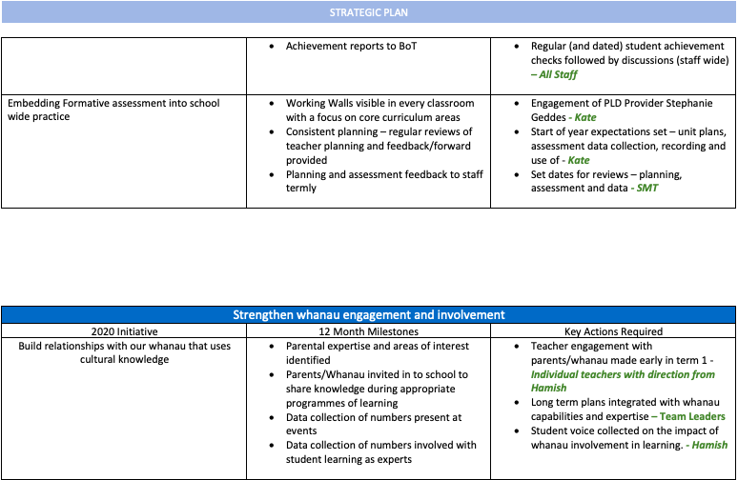

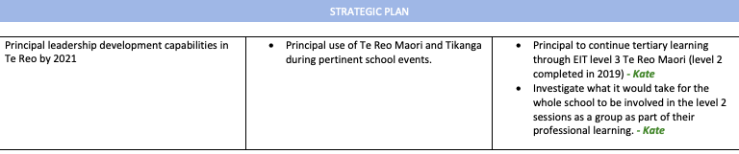

Programme of Self Review/Development

 |  | TERM ONE | TERM TWO | TERM THREE | TERM FOUR
2022 | Policies | Legislation and Administration Policy  Alcohol, Drugs and other Harmful Substances  Swimming Pool | Curriculum and Student Achievement  Emergency Planning and Procedures | Performance Management  Health, Safety and Welfare | Education Outside the Classroom  Sun Protection
 | Curriculum  Development  and Review | Parent/Maori Consultation | Health & PE Education | Literacy - Reading | Gifted and Talented
2023 | Policies | Recognition of Cultural Diversity  Staff Leave  Separated Parents, Day-to-Day Care & Guardianship | Documentation and Self-Review  Employer Responsibility | Learning Support  Appointment Procedure  Child Protection | Classroom Release Time/Timetable  Salary Units/Management Allowances  Privacy
 | Curriculum  Development  and Review | Parent/Maori Consultation | Numeracy - Mathematics | Literacy - Writing | Literacy – Visual Language
2021 | Policies | Home Learning  Financial Control | Reporting to Parents  Protected Disclosure  Visitors | Complaints  Behaviour Management | Improving Educational Outcomes for Maori  Religious Instruction/Religious Education  Harassment
 | Curriculum  Development  and Review | Parent/Maori Consultation | Inquiry – Science/Social Science | Literacy – Oral Language | Careers/languages/Technology

National Education Priorities

1. Success for all
All year 1 to 8 students will be given effectively taught programmes of learning in English, Mathematics, The Arts, Science, Social Studies, Health and Physical Education, technology and another language.
- Policies in  - place at School | - Procedures and programmes to support policy | - Supporting documentation for policies and procedures
- Assessment  - Curriculum Delivery  - Assessing Achievement Levels of Maori Students  - Reporting to Parents | - Planning from the NZ Curriculum with an emphasis on the Key Competencies.  - Curriculum Resources are purchased according to the needs of students.  - Special Needs Programmes where students work with a Teacher’s Aide and / or the classroom teacher.  - Extension Programmes where students work with a teacher.  - Variety of teaching approaches to cater for students differing learning styles and needs, specifically in a multi-level classroom.  - Use of E.O.T.C. to meet the student’s needs. | - School Planning and Assessment folder.  - Teachers’ Daily Planning Diary.  - School Master Student Management System  - School Procedure Booklet  - School Website  - BOT policy folder

2. A safe learning environment
                - Schools will provide a safe physical and emotional environment for all students.

- Policies in  place at School | - Procedures and programmes to support policy | Supporting documentation for policies and procedures
- Health & Safety  - Emergency Procedures  - Sexual Harassment  - Smoke Free  - Stand down/exclusion  - Behaviour Management  - Anti-Bullying  - Food and Nutrition | - Foster a culture of respect, caring, and tolerance through the family atmosphere of our school.  - Administration of Medicines  - Protection from Identifiable Hazards  - Internet Usage  - Enrolment / School Leavers.  - School hats in term’s one and four  - Bus behaviour contract  - Healthy foods emphasis | - BOT Policy Folder  - Administration Folder  - Medicine and first aid booklets in sickbay  - School Behaviour Booklet  - Emergency procedures booklet

3. Improving Literacy and Numeracy
School will ensure that priority is given to improving student achievement in literacy and Numeracy, especially in years 1 to 4.

- Policies in  place at School | - Procedures and programmes to support policy | Supporting documentation for policies and procedures
- Assessment  - Assessing Achievement Levels of Maori Students  - Curriculum Delivery  - Reporting to Parents | - Daily programmes are planned where Literacy and Numeracy is taught in the morning sessions which makes up 68% of the school day.  - Integrating Literacy and Numeracy into other subject areas where possible. | - School wide data and targets  - Teacher Observations  - Teachers’ Daily Planning Diary.  - Class formative planning and assessment

Special emphasis should be placed on students whose further education or training may be at risk through under achievement in Literacy and/or Numeracy.

- Policies in  place at School | - Procedures and programmes to support policy | Supporting documentation for policies and procedures
- Assessment  - Assessing Achievement Levels of Maori Students  - Curriculum Delivery  - Reporting to Parents | - Professional Development of staff in Literacy and Numeracy.  - Teacher’s Aides work in classrooms and/or withdraw children to boost their basic skills in literacy and numeracy.  - Extension groups work with a teacher to extend their literacy and numeracy skills.  - Use of the Library is encouraged and books are purchased according to needs.  - Literacy is a core practice | - Cumulative Records  - Student Profiles  - School wide data and targets  - National Exemplars, asTTle models/rubic  - NUMP Advisors, Resource Teachers  - School Professional Development  - School writing rubric  - Modelling books

4. Better use of student achievement information
Schools will gather sufficiently comprehensive assessment evidence to evaluate the progress and achievement of their students, and to inform future teaching and learning programme priorities
- Policies in  place at School | - Procedures and programmes to support policy | Supporting documentation for policies and procedures
- Assessment  - Assessing Achievement Levels of Maori Students  - Curriculum Delivery  - Reporting to Parents | - School wide data collection is based on asTTle, STAR and Running Records for Reading. NUMP, PAT and asTTle for maths.  - Teachers will gather information that is sufficiently comprehensive to enable evaluation of student progress and achievement.  - Identify students that are not achieving or who are at risk of not achieving, or who have special needs and to identify aspects of the curriculum that need special attention.  - Consult with the Maori community, to develop and make known its plans and targets for improving the achievement of Maori students | - School Planning and Assessment Books.  - Teachers’ Daily Planning Diary.  - National Exemplars  - AsTTle Reading and Maths Tests  - Advisors, Resource Teachers  - Star Reading test  - PAT Tests  - Community consultation folder  - At risk student and gifted and talented student records  - Student Profiles

5. Improving Outcomes
Drawing on dependable assessment evidence, schools will improve outcomes for all students, including those who are not achieving, or who have special learning needs

- Policies in  place at School | - Procedures and programmes to support policy | Supporting documentation for policies and procedures
- Assessment  - Assessing Achievement Levels of Maori Students  - Curriculum Delivery  - Reporting to Parents | - Setting targets for the year, which are challenging but achievable.  - Using tests, which have been nationally normed to assess and analyse our students.  - Identify students that are not achieving or who are at risk of not achieving, or who have special needs and to identify aspects of the curriculum that need special attention.  - Consult with the Maori community, to develop and make known its plans and targets for improving the achievement of Maori students | - School Planning, Assessment, Evaluation Books.  - Teachers’ Daily Planning Diary.  - Assembly – SMS.  - National Exemplars  - NUMP  - P.A.T.’s  - e-asTTLe  - Advisors, Resource Teachers  - Community consultation folder

6. Improving outcomes for Maori
Schools will work with their Maori communities to plan, set targets for, and achieve better outcomes for Maori students.

- Policies in  place at School | - Procedures and programmes to support policy | Supporting documentation for policies and procedures
- Assessment  - Assessing Achievement Levels of Maori Students  - Curriculum Delivery  - Reporting to Parents | - The Maori community is consulted through the newsletter and at celebration days, as are all parents of children at school  - The Maori Liaison person on the BOT is also used to consult with the Maori community.  - A whanau group is operating to help encourage Maori culture, language and Maori achievement  - Consult with the Maori community, to develop and make known its plans and targets for improving the achievement of Maori students | - School Planning, Assessment, Evaluation Books.  - Teachers’ Daily Planning Diary.  - Assembly Classroom Manager  - Student File  - National Exemplars  - NUMP  - P.A.T.’s  - e-asTTle  - Advisors, Resource Teachers

7. Reporting
Schools will report to students and their parents on the achievement of individual students and to the school’s community on the achievement of students as a whole and of groups identified in the national education priorities.
- Policies in  place at Ebbett Park School | - Procedures and programmes to support policy | Supporting documentation for policies and procedures
- Reporting on Student Achievement  - Community consultation  - Privacy Act | - School reports are sent out twice a year.  - Students are assessed against the national standards in reading, writing and mathematics.  - Formal parent Interviews are conducted twice a year. Informal interviews are conducted when necessary.  - Ebbett Park School has an open-door policy, school assemblies are a time for sharing our successes. Parents are welcome to join us for these occasions. At the end of each term the school will hold a big assembly to share what they covered over the term. The new curriculum approach has allowed us to have group celebrations.  - The BOT receives a curriculum report at each meeting. A number of these reports include detailed assessment, which outlines student achievement and progress of our students. Where possible there is a comparison with the previous year/s to show how we are making a difference to our students’ education over time. These reports also help identify students who need remedial or extension help. | - Cumulative Record Cards.  - Reports.  - School wide assessment data  - Principal Reports  - Profile folders

Ebbett Park School Annual Plan 2020

Curriculum Focus (NAG 1)  Annual Targets:  - Reading  - Writing  - Mathematics  Formative Assessment – development and understanding  Creation of EPS curriculum document  Development of TAI.  Technology – increased focus and integration of this curriculum | Professional Development (NAG 3)  Formative Assessment  Planning documentation developed  Cultural Responsive Practice  Digital Passport  Incredible Years (2 staff a year)  First Aid Certification | Community Partnership (NAG 2)  Half and full year reporting to parents (moved away from anniversary reporting)  Ensure feedback and next learning steps are reflected in reporting system  More active use of seesaw for informing parents of students learning  Termly ‘showcase’ days where students get to inform the community about what they have been doing
Finance (NAG 1)  Prepare budget that supports development areas and targets  Budget holder’s/Curriculum holder’s responsibilities  Budget regularly reviewed (monthly) | EBBETT PARK SCHOOL  Annual Plan 2021 | Self Review (NAG 2)  Policy and Procedure review  Strategic review  Curriculum review  Principal school review plan  Principal Reporting and review to BOT
Health and Safety (NAG 1)  Daily/weekly/monthly safety checks according to Moe requirements  Regular fire and earthquake drills once a term  First aid supply maintained  First aid training for staff on a two yearly basis  First aid training for senior classes (if appropriate) | Personnel (NAG 3)  Performance appraisal system for all staff with strong focus on Teacher as Inquiry  Opportunities to attend appropriate PD as individuals require it  Job descriptions to be reviewed  Review of policies | Grounds & Property (NAG 1)  Regular check for hazards and insect nests  Ensure appropriate device to student ratio is maintained  Consideration of Enviroschools values when designing 5YPP  Maintenance of land-space  Monitor playground equipment for replacement, removal and/or repair.

Cultural Diversity

We will recognise the cultural diversity of Aotearoa by integrating Te Reo Maori and Tikanga Maori into all curriculum areas. The school curriculum will encourage students to understand and respect the different cultures that make up New Zealand. Regular Te Reo Maori and Kapa haka lessons will ensure our students are familiar with greetings, social phrases and instructions and will emphasise the bicultural heritage that contributes to their identity as New Zealand citizens. Our Board of Trustees will consider all requests for instruction in Te Reo Maori in light of the school’s expertise and resourcing and with due consideration at the time the request is received.

Providing for Inclusive Education

We recognise student diversity at Ebbett Park School. Students with disabilities have full membership in age-appropriate classes with the appropriate support services and supplement aides. The school curriculum will encourage students to understand and respect the different abilities that make up our school. Students with a disability will unconditionally belong too and have full membership of a regular classroom in our school and its community. The school will work alongside outside agencies to enhance and support the full development of all students at Ebbett Park School.

Community Consultation in 2020

Topic | Where found
Health Education/Curriculum Review | Term 4 – Survey sent out. Results published term 1 2021
Learning Support | School Newsletter T1
Staff Leave | School Newsletter T1
Separated Parents, Day to Day care & guardianship | School Newsletter T1
Documentation and Self Review | School Newsletter T2
Employer Responsibility | School Newsletter T2
Learning Support | School Newsletter T3
Appointment Procedure | School Newsletter T3
Child Protection | School Newsletter T3
Classroom Release Time/Timetable | School Newsletter T4
Salary Units/management Allowances | School Newsletter T4
Privacy | School Newsletter T4
COVID-19 | Term 1-3 School Newsletters and survey’s sent home.  Results collated and kept on file in principal office

Community Consultation in 2021

Consultation to be carried out
Consult with community about school targets
Consultation with the community about new report format

Plans and documents that support our school charter
5 and 10 year plan
Current year budget
School policies
School procedures
Strategic plan
Teacher and Principal Appraisal
Staff Meeting records
Community Consultation Folder
School Docs: Policies and Procedures

Topic | Where found
Home Learning
Finance and Property Management
Parent and Māori Consultation

Ebbett Park School Achievement Annual Target Action Plan 2020 REVIEWED
Strategic Aim: To increase student performance as they transition from ECE to Primary School
Target Outcomes  - 100% of those students transitioning from ECE to Primary school will be ‘school ready’ after 6 months in the transition class |  | Historical Data  20 Weeks: 15 learners are at 20 weeks: Of the 20-week testing after the observational survey 8 were still emergent, 4 were on level 2, Two learners are on level 3 and 1 on level 4. Four learners know less than 10 letters, 8 are still stanine 1. 4 learners are stanine 2, 2 are stanine 4 and I is stanine 5. Only 3 learners have moved off stanine 1 for word recognition and only 1 has a stanine higher than stanine for concepts about print.  40 weeks: 8 learners of the 20 are at 40 weeks. 2 learners are on level 3 and the remaining 6 are still emergent. These 6 have been placed on Reading Recovery wait list. Only 1 of the 8 knows less than 8 letters. 3 remain stanine 1 for letter Identification. 4 are stanine 2 and 1 is stanine 4. They are all still stanine 1 for basic sight words and 3 of the 8 have moved to stanine 2 instead of a 1 for concept about print.
Curriculum Area  School Wide | Year Level  NE | Target Group:  All NE students due to join EPS during the year. Individual students identified
ACTIONS TO ACHIEVE TARGETS |  | Led by Budget | Timeframe
Maintain the relationships between EPS and the ECEs |  | Principal and NE/transition teacher | T1
Continue the weekly visits of the ECE to EPS |  | Principal and NE/transition teacher | T1
Transition class set up and established from the beginning of the year |  | Principal/DP/BoT | T1
Observations to identify ‘school readiness’ of NE students and ensure placement into either transition class or NE class. |  | NE/transition teachers/DP/Senco | ON Going
Establish transition protocol of students moving from transition class into the NE class |  | Principal/DP/NE and transition teachers | T2

Actions  What did we do? | Outcomes  What happened? | Reasons for the variance  Why did it happen? | Evaluation  Where to next?
Maintain the relationship between EPS and ECEs  Continue the weekly visits for the ECE to EPS  Transition class set up and established from the beginning of the year  Observations to identify ‘school readiness’ of NE students and ensure placement into either transition  Established transition protocol of students moving from transition class into the NE class | In regard to achievement level of our NE/Year 1 students at the end of 2019 we had:  Reading: 43% reaching expected curriculum level  Writing: 8% reaching expected curriculum level  Math: 57% reaching expected curriculum level.  In regard to achievement level of our NE/Year 1 students at the end of 2020 we have:  Reading: 58% reaching expected curriculum level.  Writing: 12.5% reaching expected curriculum level.  Math: 29.2% reaching expected curriculum level.  NE teacher has commented on the focus of the learners and a noted positive behaviour throughout the class. Working with individuals was easier and allowed greater learning to take place. The transition of students in and out (due to numbers) was easier and ensured less disruption.  While some academic improvement has been made it is not as significant as we would have liked. | The concept and thinking around the transition class is wonderful. We have noticed calmer environments in both the transition and NE classes. Learning can be more directed to a new learner and allows them to be set up for success further down the track. The NE class is also able to focus on learning rather than structure, routines and behaviours.  However, while the learning improvement is evident in Reading and writing it is not so in Math and this is not the desired outcome.  The lack of improvement academically has been hindered by the extensive time that was spent away from school as a result of COVID and lockdown. Had we been able to have a whole, consistent, year with this running I feel we would have had greater success academically. | While it would be great to be in the position for the transition class to continue from the beginning of the 2021 academic year this is not feasible due to the decrease in staffing for 2021.  However, the aim is to be in a position to establish the transition class to begin again in term 2. This will also be dependent of having the ‘right’ fit in regard to staffing this position.  Tracking of the 2019 and 2020 cohort of students will continue to see how they fair further down the line and the comparison of transition vs non-transition class.
Planning for next year:
Aim to employ a teacher for term 2 with the purpose of establishing the transition class again. This is going to depend on staffing and may require consultation with the Board of Trustees in regard to the benefit of this initiative and the employment via Board funds.
Continue to track the learners in both the 2019 and 2020 NE cohorts to ensure the data around achievement and progress is collected as evidence around this initiative.

Ebbett Park School Achievement Annual Target Action Plan 2020 REVIEWED
Strategic Aim: To increase the number of students writing at their curriculum Level
Target Outcomes  - 80% of the ‘at risk’ and ‘of concern’ students will make accelerated progress by the end of the 2020 academic year.  - 100% of the students that are achieving will sustain their achievement and continue their progress. |  | Historical Data  Our Asian students have the strongest ability in this area with 75% at/above curriculum level. Followed by our European/Pākehā with 59.3% and Māori with 53.1%. It is our Pasifika students that are struggling in this area with only 40% at/above. Our girls are achieving with 64.3 at/above but the boys lag behind with only 40.9% at/above. This disparity between boys and girls is the biggest in this curriculum area. Our junior school that are struggling to reach the desired curriculum level with years 1 - 3 achieving between 42.9% - 48.1%. Our senior students do struggle in this area with year 4 having 56% at/above and year 5 51.6%. Our year 6 group is attaining close to 80% achievement rate (79.1%). Writing is a curriculum area that needs a great deal of focus with targeted teaching given to boys in all ethnic groups except our Asian students and it needs to have a strong focus within the junior school. Directed and guided writing needs to be happening EVERY DAY for every student.
Curriculum Area  Writing | Year Level  Y1 - 3 | Target Group:  Year 1-3: All below curriculum level students
ACTIONS TO ACHIEVE TARGETS |  | Led by Budget | Timeframe
Directed and targeted teaching of writing in all junior classrooms |  | Team Leader | Throughout the year
Design and establish a ‘writing curriculum’ for EPS |  | Literacy leader supported by Principal and DP | Throughout the year
Collaborative planning |  | Junior Team | T1 and ongoing
Establish data tracking and review regularly |  | Principal/DP | T1 and ongoing
School timetable to identify non-negotiable times where literacy MUST take place (4x 1hours sessions/wk.) |  | Principal | Before year begins
Regular staff meetings that focus on student achievement |  | All staff – in teams | Each term
Regular reporting to BoT around the progress of the target students |  | Principal | End of each term
Teacher as Inquiry with Writing focus established as a progression from the Reading set at beginning of year |  | Principal and outside facilitator | Second half of the year

Actions  What did we do? | Outcomes  What happened? | Reasons for the variance  Why did it happen? | Evaluation  Where to next?
Junior classrooms initiated an across team writing programme. This took place at the same time each day and across years NE-Y3, 5 classrooms.  Collaborative planning took place across the junior team.  The junior team met regularly to discuss the achievement of the learners in this cohort and shared data across the team to ensure learners needs were targeted and met. | In regard to achievement level of our NE – Year 3 students at the end of 2019 we had:  26 learners reaching expected curriculum level and 55 not. This equates to 32% and 68%  In regard to achievement level of our NE – Year 3 students at the end of 2020 we have:  41 learners reaching expected curriculum level and 51 not. This equates to 45% and 55%. | Improvement in achievement has been made over the year.  However, improvement could have been hindered by the extensive time that was spent away from school as a result of COVID and lockdown. Had we been able to have a whole, consistent, year with this running I feel we would have had greater success academically. | Establish ‘curriculum experts’ across curriculum subjects. These experts will have a knowledgeable input into the design of our Localised curriculum, will be the ‘leader’ that others seek direction and advice from (consistency)  Maintain ‘non-negotiable’ teaching timetable school-wide.  Design on formal writing programme at EPS
Planning for next year:
Establish a school-wide writing programme/curriculum to ensure ALL students are exposed to, gain experience and practice in writing that ensure the improvement of knowledge, skill and achievement.

Ebbett Park School Achievement Annual Target Action Plan 2020 REVIEWED
Strategic Aim: To increase the number of students achieving at their curriculum Level for math
Target Outcomes  - 80% of the ‘at risk’ and ‘of concern’ students will make accelerated progress by the end of the 2020 academic year.  - 100% of the students that are achieving will sustain their achievement and continue their progress. |  | Historical Data  Our European/Pākehā students have successful experiences with math. They are the only group that have above 70% at/above (70.4%). There is a significant struggle by our Asian students to achieve in math with only 25% at/above. Our Māori students sit at 63.9% while our Pasifika are only able to attain 56.7% at/above curriculum. Our girls are stronger in this curriculum area than our boys with girls having 69.1% at/above and only 57.5% at/above. Our year 2 group are achieving well with 70.4% at/above. They are only marginally behind the year 6's who have 75% at/above. The year 3 group are achieving the least here with only 50% of the group at/above. Year 1 students have 56.2% at/above while year 4 and 5 are closely aligned with 68% and 64.6%. Our targeted teaching needs to be focusing on our Asian and Pasifica students with a major focus on our boys and within the first and 3rd year of schooling.
Curriculum Area  Math | Year Level  Y4 students | Target Group:  Year 4: All students in this year group
ACTIONS TO ACHIEVE TARGETS |  | Led by Budget | Timeframe
Directed and targeted teaching of mathematics in all junior classrooms |  | Team Leader | Throughout the year
Design and establish a ‘Numeracy curriculum’ for EPS |  | numeracy leader supported by Principal | Throughout the year
Collaborative planning |  | Junior Team | T1 and ongoing
Establish data tracking and review regularly |  | Principal/DP | T1 and ongoing
School timetable to identify non-negotiable times where numeracy MUST take place (4x 1hours sessions/wk.) |  | Principal | Before year begins
Regular staff meetings that focus on student achievement |  | All staff – in teams | Each term
Regular reporting to BoT around the progress of the target students |  | Principal | End of each term
Teacher as Inquiry with Writing focus established as a progression from the Reading set at beginning of year |  | Principal and outside facilitator | Second half of the year
Continue and sustain mathematics cross-grouping within the senior school |  | Team leader | Throughout the year

Actions  What did we do? | Outcomes  What happened? | Reasons for the variance  Why did it happen? | Evaluation  Where to next?
Senior classrooms initiated an across team math programme. This took place at the same time each day and across years Y4-6, 3 classrooms.  Collaborative planning took place across the senior team.  The senior team met regularly to discuss the achievement of the learners in this cohort and shared data across the team to ensure learners needs were targeted and met. | In regard to achievement level at the end of year for this cohort in 2019 students were year 3:  14 learners reaching expected curriculum level and 14 not. This equates to a 50/50 balance across this cohort.  In regard to achievement level at the end of year for this cohort in 2020 students were year 4:  11 learners reaching expected curriculum level and 16 not. This equates to 41% and 59%.  If you compare end of year data to the beginning of year data for the 2020 Year 4 cohort this is evidence of improvement:  At/Above: T1: 8, T4: 11  Below/Well Below: T1 19, T4: 16.  This shows a shift of 3 students. | Improvement in achievement has been made over the year.  However, improvement could have been hindered by the extensive time that was spent away from school as a result of COVID and lockdown. Had we been able to have a whole, consistent, year with this running I feel we would have had greater success academically. | Establish ‘curriculum experts’ across curriculum subjects. These experts will have a knowledgeable input into the design of our Localised curriculum, will be the ‘leader’ that others seek direction and advice from (consistency)  Maintain ‘non-negotiable’ teaching timetable school-wide.  Design on formal math programme at EPS
Planning for next year:
Establish a school-wide math programme/curriculum to ensure ALL students are exposed to, gain experience and practice in writing that ensure the improvement of knowledge, skill and achievement

Ebbett Park School Achievement Annual Target Action Plan 2020 REVIEWED
Strategic Aim: To increase the number of students reading at their curriculum Level
Target Outcomes  - 80% of the ‘at risk’ and ‘of concern’ students will make accelerated progress by the end of the 2019 academic year.  - 100% of the students that are achieving will sustain their achievement and continue their progress. |  | Historical Data  Our European/Pākehā students are the group meeting milestones the best with 59% at/above curriculum level, this is followed by our Asian group of students who have 50% at/above. Our Pasifika and Māori students are the group struggling to meet curriculum level. It is also our boys that are struggling to meet level with only 37.5% at/above. There is a significant challenge in our junior school with none of the years 1-3 reaching about 37% at/above. This is an alarming result. As the senior student’s progress through the years there is an improvement in achievement each year: year 4 has 56% at/above curriculum level, 61.3% for our year 5 group and 75% of our year 6 group are at/above. 75% is where each group needs to be reaching and this is not yet being achieved. While we have students involved in Reading Recovery Programme (a greater number than the usual) we are still not seeing the progress that we want. There needs to be a directed focus on boys, Māori and Pasifika students within the junior school. This low achievement puts a great deal of pressure on all teaching staff as these student’s progress throughout the years.
Curriculum Area  Reading | Year Level  NE-Y6 students | Target Group:  Year NE- 3: All students in these year groups
ACTIONS TO ACHIEVE TARGETS |  | Led by Budget | Timeframe
School Wide professional Development: teaching to ensure progress in literacy – Tātai Angitu, Massey. |  | Christine Braid | TOD beginning of year
Directed and targeted teaching of reading in all junior classrooms |  | Team Leader | Throughout the year
Design and establish a ‘Reading curriculum’ for EPS that includes ‘5 a day’ concept/strategy |  | Literacy leader supported by Principal and DP | Throughout the year
Collaborative planning |  | Junior Team | T1 and ongoing
Establish data tracking and review regularly |  | Principal/DP | T1 and ongoing
School timetable to identify non-negotiable times where literacy MUST take place (4x 1hours sessions/wk.) |  | Principal | Before year begins
Regular staff meetings that focus on student achievement |  | All staff – in teams | Each term
Regular reporting to BoT around the progress of the target students |  | Principal | End of each term
Teacher as Inquiry with reading focus established as a result of beginning of the year PD |  | Principal and outside facilitator | TOD beginning of the year.

Actions  What did we do? | Outcomes  What happened? | Reasons for the variance  Why did it happen? | Evaluation  Where to next?
All staff participated in TEPIL Professional Development at the beginning of 2020.  Junior team worked with the support of Christine Braid to trial and implement this programme into their classroom and establish it as an expectation as part of the reading programme for those at risk learners.  Collaborative planning took place across the junior team.  The junior team met regularly to discuss the achievement of the learners in this cohort and shared data across the team to ensure learners needs were targeted and met.  Set non-negotiable reading time School wide.  Full time Reading Recovery teacher as well as another teacher in training. | In regard to achievement level at the end of year for this cohort in 2019 students were:  22 learners reaching expected curriculum level and 98 not.  In regard to achievement level at the end of year for this cohort in 2020 students were year 4:  28 learners reaching expected curriculum level and 50 not.  If you compare end of year data to the beginning of year data for the 2020 cohort there is evidence of improvement:  At/Above: T1: 18, T4: 28  Below/Well Below: T1 53, T4: 50. | Improvement in achievement has been made over the year.  However, improvement could have been hindered by the extensive time that was spent away from school as a result of COVID and lockdown. Had we been able to have a whole, consistent, year with this running I feel we would have had greater success academically. | Establish ‘curriculum experts’ across curriculum subjects. These experts will have a knowledgeable input into the design of our Localized curriculum, will be the ‘leader’ that others seek direction and advice from (consistency)  Maintain ‘non-negotiable’ teaching timetable school-wide.  Expected implementation of the TEPIL programme in each class targeting selected students. – this group of students are to be monitored and tracked for progress.  Continued employment of a Reading Recovery Teacher in a full time position (aim to cover a greater number of learners)
Planning for next year:
Establish a school-wide Reading programme/curriculum to ensure ALL students are exposed to, gain experience and practice in writing that ensure the improvement of knowledge, skill and achievement

Ebbett Park School Achievement Annual Target Action Plan 2021
Strategic Aim: All learners will access the New Zealand Curriculum as evidenced by (accelerated) progress and achievement. The curriculum is used effectively to support improvement in learner’s outcomes.
Target Outcomes  Target group of 15 current year 3 learners who achieve 'below' or 'well below' for their end of year 2 curriculum achievement in reading. Within this target group there are subsets who need different rates of progress. This target group has been selected because this group was the largest 'below’ group in school in 2020 end of year data. 13 of this group are male and 10 of these learners are Māori. |  | Historical Data  Our results are not as pleasing as they have been in the past. Our year 3, 5 and 6 group students are the only cohorts to obtain 60% at or above curriculum in Reading: Y6 (65%), Y5 (67%) and Y3 (60%). The other 3 year groups performed disappointingly with Y1s only reaching 13%, Y2 29% and Y4 37%. There is a 5% difference in reading achievement between male and female with the girls achieving 5% higher than the boys at 50%. Our Asian students are the strongest achievers in Reading. They have 57% at or above. This is followed by our Māori learners at 46% closely followed by NZE at 45%. Our Pasifika students have the lowest performance at 31%.
Curriculum Area  READING | Year Level  NE – Y6 | Target Group:  Year 3 learners as specified: 13 of this group are male and 10 of these learners are Māori. (Alexis, Ben, George, Grayson, JJ, Karaitiana, Kydan, Lachlan, Mahina, Manawai, Junior, Rakena, RJ and Tangaroa)
ACTIONS TO ACHIEVE TARGETS |  | Led by Budget | Timeframe
Directed and targeted teaching of reading in all junior classrooms |  | Team Leader | Throughout the year
Targets classroom groups involved in specific reading programmes: TEPIL, Reading Recovery Group |  | Principal/DP | T1 and ongoing
Design and establish a ‘Place based curriculum’ for EPS |  | Literacy leader supported by Principal and DP | Throughout the year
Collaborative planning |  | Junior Team | T1 and ongoing
Establish data tracking and review regularly |  | Principal/DP | T1 and ongoing
School timetable to identify non-negotiable times where literacy MUST take place (4x 1hours sessions/wk.) |  | Principal | Before year begins
Regular staff meetings that focus on student achievement |  | All staff – in teams | Each term
Regular reporting to BoT around the progress of the target students |  | Principal | End of each term
Teacher as Inquiry with Reading focus |  | Principal and outside facilitator | Second half of the year

Ebbett Park School Achievement Annual Target Action Plan 2021
Strategic Aim: All learners will access the New Zealand Curriculum as evidenced by (accelerated) progress and achievement. The curriculum is used effectively to support improvement in learner’s outcomes.
Target Outcomes  Target group of 39 male learners across the school who achieves 'below' or 'well below' for their end of year achievement in writing. Within this group there are subsets who need different rates of progress. This target group has been selected because this group is the 'below' cohort in school in 2020 end of year data. 25 of these learners are Māori, 8 NZE, 5 Pasifika and 1 Asian. |  | Historical Data  Writing is the poorest performance across the curriculums with only the year 5 and 6 cohorts achieving above 50% - Year 5 58% and Year 6 65% attainment. It is a curriculum area that our boys significantly struggle with, only 36% achieving at or above. The girls are only marginally ahead of the boys at 47% attainment. Our Asian learners are our strongest achievers in this curriculum area with an attainment of 71% followed by our NZE learners at 50%, Māori at 42% and Pasifika at 27%.
Curriculum Area  WRITING | Year Level  NE – Y6 | Target Group:  39 Males across all levels of the school as specified: (Aiden, Jayden, Kohrus, Lars, Leo, Stylee, Ben, George, Grayson, JJ, Karaitiana, Kydan, Lachlan, Manawai, Junior, Rakena, RJ, Harlem RT, Luke, Wetini, Jah, Lorenzo, Makaire, max, Robert, Royal, Sayful, Trinity, AJ, Bowen, Flynn, Kobie TC, Jahzaeya, James, Manaia H, Mua, Royalty, Tane and Warratah)
ACTIONS TO ACHIEVE TARGETS |  | Led by Budget | Timeframe
Directed and targeted teaching of writing in all junior classrooms |  | Team Leader | Throughout the year
Targets classroom groups involved in writing programmes |  | Principal/DP | T1 and ongoing
Design and establish a ‘Place Based curriculum’ for EPS |  | Literacy leader supported by Principal and DP | Throughout the year
Collaborative planning |  | Junior Team | T1 and ongoing
Establish data tracking and review regularly |  | Principal/DP | T1 and ongoing
School timetable to identify non-negotiable times where literacy MUST take place (4x 1hours sessions/wk.) |  | Principal | Before year begins
Regular staff meetings that focus on student achievement |  | All staff – in teams | Each term
Regular reporting to BoT around the progress of the target students |  | Principal | End of each term
Teacher as Inquiry with Writing focus |  | Principal and outside facilitator | Second half of the year
Ebbett Park School Achievement Annual Target Action Plan 2021
Strategic Aim: All learners will access the New Zealand Curriculum as evidenced by (accelerated) progress and achievement. The curriculum is used effectively to support improvement in learner’s outcomes.
Target Outcomes  Target group of 30 year 4 and 5 learners who achieved 'below' or 'well below' for their end of year 3 and 4 curriculum achievement in math. Within this target group there are subsets who need different rates of progress. This target group has been selected because these groups obtained significantly lower attainment in school 2020 end of year data. In this cohort 18 are female and 12 are male and are made up of 21 Māori, 6 NZE and 3 Pasifika |  | Historical Data  Math is a strong curriculum area with higher attainment across a majority of the year levels. This is again dominated by our year 5 and 6 and surprisingly our year 1 learners. Our year 5s have the highest attainment at 79% followed equally by year 1 and 6 at 58%. There is a disappointing drop to 44% at year 3 and 41% at year 4 which then continues to decline further with the year 2 learners only reaching 25% at or above curriculum level. Both males and females are performing closely together with females at 51% and Males at 52%. Our strongest performers are, again, our Asian students (86%) followed by NZE at 63%, Māori at 50% and Pasifika at 31%
Curriculum Area  MATH | Year Level  NE – Y6 | Target Group:  Group of 30 Year 4 and 5 learners as specified (
ACTIONS TO ACHIEVE TARGETS |  | Led by Budget | Timeframe
Directed and targeted teaching of math in all classrooms |  | Team Leader | Throughout the year
Targets classroom groups involved in math programmes |  | Principal/DP | T1 and ongoing
Design and establish a ‘Place Based curriculum’ for EPS |  | Literacy leader supported by Principal and DP | Throughout the year
Collaborative planning |  | Junior Team | T1 and ongoing
Establish data tracking and review regularly |  | Principal/DP | T1 and ongoing
School timetable to identify non-negotiable times where literacy MUST take place (4x 1hours sessions/wk.) |  | Principal | Before year begins
Regular staff meetings that focus on student achievement |  | All staff – in teams | Each term
Regular reporting to BoT around the progress of the target students |  | Principal | End of each term
Teacher as Inquiry with Math focus |  | Principal and outside facilitator | Second half of the year

